Project Name



Submitted By

Session

Project Supervisor

Department Name
School of Systems and Technology
University of Management and Technology
C-II Johar Town Lahore Pakistan

Dedication

Final Approval
Project Name

Panel of Examiners

- Head of Department ______________________
Department of Software Engineering
University of Management and Technology
Lahore

- Program Director ( Final Year Projects) ______________________
Department of Software Engineering
University of Management and Technology
Lahore

- Supervisor ______________________
Department of Software Engineering
University of Management and Technology
Lahore

- Co-Supervisor ______________________
(If any)

- Documentation Evaluator ______________________

Acknowledgment

Project Title
Objective

Undertaken by

Supervised by
Starting Date

Completion Date

Tools Used
Operating System
Documentation

Plagairism Report

Declaration Form

I have carefully examined the documentation of the Final Year Project titled “Project title”; and I endorse that this documentation complies with the standards of an undergraduate level Final Year Project report.
The document has been checked for plagiarism through Turnitin software available in UMT Library. The similarities of the document are within acceptable range.
Moreover, the accompanying CDs contain PDF of the documentation, as well as the source code and binaries with user manual and installation guide.

FYP Supervisor Name: ______________________________

Signature: __________________ Date:___________________

Abstract

Revision Chart
This chart contains a history of this document’s revisions. The entries below are provided solely for illustration purposes. Those entries should be deleted until the revision/s they refer to have actually been created.
The document itself should be stored in revision control, and a brief description of each version should be entered in the Revision Control System. A brief description can be repeated in this section. Revisions need not be described elsewhere in the document, unless they explain the document.

Version | Primary Author(s) | Description of Version | Date Completed
Draft | TBD | Initial draft created for distribution and review comments | (To be decided) TBD
Preliminary | TBD | Second draft incorporating initial review comments, distributed for final review | TBD
Final | TBD | First complete draft, which is placed under change control | TBD
Revision 1 | TBD | Revised draft, revised according to the change control process and maintained under change control | TBD
Revision 2 | TBD | Revised draft, revised according to the change control process and maintained under change control | TBD
Etc. | TBD | TBD | TBD

Table of Contents
New paragraphs formatted as Heading 1, Heading 2, and Heading 3 will be added to the table automatically. To update this table of contents in Microsoft Word, put the cursor anywhere in the table and press F9. If you want the table to be easy to maintain, do not change it manually.
Table of Contents 1
Definitions and Acronyms 4
List of Figures 5
List of Tables 7
1. Introduction 8
1.1 Problem Statement 9
1.2 Objectives 9
1.3 Scope of the Project 9
1.4 Significance of the Project 10
1.5 Artiificial Intelligence features 10
1.6 Project Deliverables 10
2. Domain Analysis 11
2.1 Customer 11
2.2 Stakeholders 11
2.3 Affected Groups with social or economic impact 12
2.4 Dependencies/ External Systems 13
2.5 Related Projects with feature comparision 14
2.5.1 Related Projects 14
2.5.2 Feature Comparison 15
2.6 Context Diagram 16
2.7 Data Flow Diagram Level 0 17
3. Requirements analysis 19
3.1 List of Actors 19
3.2 Product Backlog 19
3.2.1 Course Catalog 22
3.2.2 Account Management 23
3.2.3 Course Creation 25
3.2.4 Buying Courses 26
3.2.5 License Admin 27
3.2.6 Viewing Courses 28
3.2.7 Course Completion 29
3.2.8 Miscellaneous 29
3.2.9 Forms 30
3.2.10 Announcements 31
3.2.11 Quizzes 31
3.2.12 Non-Functional Requirements 33
3.2.13 Affiliates 33
3.2.14 Comments 34
3.2.15 Course Evaluation 34
3.2.16 Reporting 35
3.3 Figma UI/UX Designs 37
4. Project Planning and Execution using Sprints 53
4.1 Jira 53
4.2 Slack 53
4.3 Github Repository 53
4.4 Sprint 1 53
4.4.1 Sprint 1 Planning Meeting Minutes 53
4.4.2 Sprint 1 Backlog 55
4.4.3 Sprint 1 Design Class Diagram 58
4.4.4 Sprint 1 Sequence Diagram 59
4.4.5 Sprint 1 Decision Table 60
4.4.6 Sprint 1 Extended Test Cases 61
4.4.7 Sprint 1 Review Meeting 62
4.4.8 Sprint 1 Retrospective Meeting 64
5. System Architecture 66
5.1 System context Diagram 66
5.2 System Container Diagram 67
5.3 Component Diagram 68
5.4 Code Diagrams 69
5.5 ERD 70
5.6 Data Dictionary 72
6. Implementation details 73
6.1 Development Setup 73
6.2 Deployment setup 73
6.3 Algorithms 73
6.4 Constraints 73
6.4.1 Assumptions 73
6.4.2 System constraints 73
6.4.3 Restrictions 73
6.4.4 Limitations 73
7. Project Monitoring, control and traceability 74
7.1 Traceability Matrix 74
7.1.1 Requirements vs Prototype (PB-ID vs PID) 74
7.1.2 Requirements vs Test Cases (PB-ID vs TID) 75
8. Results/Output/Statistics 77
8.1 %completion 77
8.2 %accuracy 77
8.3 %correctness 77
9. Conclusion 78
10. Future work 79
11. Bibliography 80
11.1 Books 80
11.2 Journals 80
11.3 Articles 80
11.4 Research papers 80
11.5 Other References 80
12. Appendix 81
12.1 Glossary of terms 81
12.2 Pre-requisites 81

Definitions and Acronyms
Provide definitions or references to all the definitions of the special terms and acronyms used within this document

Table 1 : List of acronyms and definitions
Acronym | Definition
UMT | University of Management and Technology
CTS | Chemical Tracking System

List of Figures
New figures that are given captions will be added to the table automatically.
- Insert caption:
  - select picture
  - right click
  - select “insert caption”
  - under “options”, choose label as “figure”
  - Under “caption”, an automatic insertion of “figure no” will appear. Give your figure an appropriate caption
- Update list of figures:To update this list in Microsoft Word, put the cursor anywhere in the table and press F9.
- Note: If you want the table to be easy to maintain, do not change it manually.

Figure 1: Context Diagram - Chemical Tracking System [1] 16
Figure 2: Data Flow Diagram - Chemical Tracking System[1] 17
Figure 3: Epic vs User Story in Product Backlog [1] 19
Figure 4: Prototype - PID1- Sign Up Page UI 37
Figure 5: Prototype - PID2- Sign In Page UI 38
Figure 6: Prototype - PID3- Home Page UI Partial 39
Figure 7: Prototype - PID4- Course Listing Page 40
Figure 8: Prototype - PID5- Course Details Page 41
Figure 9: Prototype - PID6- Cart Page 42
Figure 10: Prototype - PID7- Checkout Page 43
Figure 11: Prototype - PID8- Instructor Registration Page 44
Figure 12: Prototype - PID9- Instructor Listing Page 45
Figure 13: Prototype - PID10- Instructor Detail Page 46
Figure 14: Prototype - PID11- Student Registration Page 47
Figure 15: Prototype - PID12- Pricing Page 48
Figure 16: Prototype - PID13- Event Listing Page 49
Figure 17: Prototype - PID14- Event Detail Page 50
Figure 18: Prototype - PID14- 404 Page 51
Figure 19: Prototype - PID14- FAQs Page 52
Figure 20: Class diagram of Sprint 1 features [4] 58
Figure 21: Sample Sprint 1 Sequence diagram POS 1 [2] 59
Figure 22: Sample Sprint 1 Sequence diagram POS [2] 60
Figure 23: Sample Sprint 1 Decision Table Chemical Tracking System 60
Figure 24: System context Diagram [5] 66
Figure 25: System container Diagram [5] 67
Figure 26: Component Diagram [5] 68
Figure 27: Component Diagram [5] 69
Figure 28: ER Diagram for University Scenario [3] 71
Figure 29: Data Dictionary of Chemical Tracking System [1] 72

List of Tables
New Tables that are given captions will be added to the table automatically.
- Insert caption:
  - select table
  - right click
  - select “insert caption”
  - under “options”, choose label as “table”
  - Under “caption”, an automatic insertion of “table no” will appear. Give your table an appropriate caption
- Update table: To update this table of contents in Microsoft Word, put the cursor anywhere in the table and press F9.
- Note: If you want the table to be easy to maintain, do not change it manually.

Table 1 : List of acronyms and definitions 4
Table 2: List of Stakeholders 11
Table 3: Feature comparison of our product with competitors 15
Table 4: Selected Features of Product Backlog 53
Table 5: Team Capacity Sprint 1 55
Table 6: Sprint 1 Backlog 55
Table 7: Sprint 1 Exteneded Test Case 61
Table 8: Status of Sprint 1 Backlog 62

Introduction
Access to timely, culturally sensitive mental-health care is severely limited in Pakistan. There are fewer than 0.5 psychologists per 100,000 people, most professionals are concentrated in urban centers, and many rural or low-resource communities have virtually no local access to counseling. On top of that, language diversity, low literacy, digital-literacy gaps and cultural stigma around mental health prevent many people from seeking help even where services exist. Sakoon AI was motivated by these real, measurable barriers and the need for a safe, scalable way to provide first-line mental-health support to underserved populations.
Sakoon AI is an AI-powered virtual therapist that delivers voice-first, emotionally adaptive, multilingual mental-health support through a humanoid avatar that simulates a face-to-face, video-session experience. It combines speech recognition and natural-language understanding for regional dialects, affective computing to sense emotion in voice, LLM-driven empathetic dialogue, mood tracking and basic crisis detection — all available 24/7.

People in remote or low-resource areas with little or no access to human therapists.Low-literacy or non-English speakers (supports regional languages such as Urdu and voice interaction).Users reluctant to seek in-person care due to stigma — they can engage privately with the avatar.Healthcare systems and NGOs looking to scale mental-health outreach and early-warning screening.

Problem Statement
Current digital mental-health solutions have important limitations: many are text-only chatbots that work primarily in English; emotion detection is often primitive or absent; few provide voice interaction or culturally localized content; and almost none offer a live, avatar-based, video-like therapeutic experience or easy escalation to human professionals when needed.These gaps mean existing tools fail to reach large sections of the population who need low-friction, voice-first, culturally adapted care. Sakoon AI aims to close those gaps by combining multilingual ASR/NLU, affective computing, an empathetic dialogue engine, a humanoid avatar for immersive sessions, and human-in-the-loop escalation for high-risk cases

Objectives

Primary objectives
- Build an accessible, voice-first virtual therapist that reduces the mental-health treatment gap (core mission / purpose).
- Provide 24/7 empathetic, culturally relevant support that works for low-literacy users (accessibility + impact).
- Detect distress early and enable safe, automated escalation to human professionals when needed (safety & crisis intervention).
- Ensure privacy-first, secure handling of user data and consented data flows (trust & compliance).
- Deliver a scalable, highly available platform (web + mobile) capable of serving millions of users (reliability & growth).

Secondary objectives
- Offer subscription / service models for institutions and individuals to create sustainable revenue streams (business model).
- Provide admin tools and dashboards for monitoring usage, reviewing sessions, and managing escalations (operations & governance).
- Support multilingual and regional dialects (e.g., Urdu + English + dialects) and robust ASR/NLU tuned for noisy, regional speech (localization & usability).
- Implement affective computing / emotion-aware responses and personalized recommendations (clinical effectiveness & personalization).
- Track mood and behaviour for measurable progress and tailored interventions (outcome measurement).
- Maintain human-in-the-loop handoff for complex or high-risk cases and follow ethical AI practices (clinical oversight & ethics).

Scope of the Project
Included in Scope:
- Voice-first conversational therapy — natural speech input and output to support low-literacy users.
- Multilingual support — initial support for English and Urdu (with provision to add regional dialects later).
- Humanoid avatar (video-style session) — 3D avatar with lip-sync and facial expressions to simulate a face-to-face session.
- Mood & behavior tracking — daily voice check-ins, activity logs, and trend reports for users.
- Adaptive/personalized content — simple personalization engine that adapts psychoeducation and coping exercises based on user history and mood.
- Basic crisis detection & escalation — automated risk detection with scripted crisis guidance and a human-in-the-loop escalation pathway.
- Psychoeducation modules — CBT-style exercises, quizzes, guided coping techniques and short counseling sessions.
- Cross-platform delivery — a web app (and a mobile-friendly interface) for user interaction and an admin dashboard for monitoring.
- Security & privacy fundamentals — secure authentication, encrypted storage/transfer for user data, basic access controls.

Non-functional goals — usability (simple interface), 24/7 availability target (within hosting limits), scalability design considerations, and maintainability.
Out of Scope:
- Clinical diagnosis or treatment — the system will not provide formal medical diagnoses, prescribe medication, or replace licensed mental-health professionals.
- Full regulatory certification — obtaining medical device / healthcare regulatory approvals (e.g., formal clinical validation studies) is not included.
- Extensive multi-language coverage at launch — only English and Urdu (and a limited set of dialects) are planned for the project timeline; wide national language support is future work.
- Wearable / biosensor integration — full hardware integration (wearables or continuous physiological monitoring) is excluded. (Basic biofeedback concepts may be discussed, but hardware support is out of scope.)
- Offline-only capability — the platform requires internet access for ASR, NLU, and server-side models; fully offline operation is not provided.
- 24/7 live human therapists — while escalation to professionals is enabled, providing live human therapists around the clock is out of scope.
- Enterprise / national scale deployment — full production rollout to millions of active users with SLAs is beyond the FYP; we will design for scalability but not perform a nationwide deployment.
- Advanced medical-grade biosignal analysis — in-depth physiological diagnostics (ECG, EEG, etc.) are excluded.

Significance of the Project
This project is significant because it addresses the growing mental-health support gap by providing an accessible, affordable, and technology-driven solution. Sakoon AI offers 24/7 voice-based emotional support, helping users who face barriers such as stigma, limited access to professionals, and low literacy. By enabling early mood tracking and crisis detection, the system supports timely intervention and promotes preventive mental healthcare.

From an academic perspective, the project contributes to research in artificial intelligence, affective computing, and human-computer interaction by exploring voice-based therapy, multilingual natural language processing, and personalized AI responses. From an industry standpoint, it demonstrates how AI-driven virtual therapy systems can be localized and scaled for real-world deployment. Socially, the project has the potential to improve mental well-being, reduce healthcare burden, and encourage help-seeking behavior, particularly in underserved communities.

Artiificial Intelligence features
This section lists concrete scenarios where AI powers Sakoon AI’s functionality, showing how machine learning, NLP, computer vision, and affective computing are applied to deliver a voice-first, culturally aware virtual therapist.

- Voice recognition & regional ASR: Convert user speech (Urdu, English, regional dialects) to text reliably so users can speak naturally. This enables hands-free sessions and low-literacy access.
- Spoken-language understanding (NLU): Extract intent, user concerns, and clinical-relevant slots (e.g., sleep, appetite, suicidality) from transcribed speech to decide next actions or therapeutic prompts.
- Affective analysis from voice: Detect emotional cues (sadness, anxiety, anger, arousal) from tone, pitch, and speech rate to adapt empathy level, ask follow-up questions, or trigger calming exercises.
- Empathetic response generation (LLM + safety): Generate context-aware, culturally respectful therapeutic replies, guided by safety rules and therapy scripts to maintain compassion and clinical boundaries.
- Personalization & recommendation engine: Use interaction history, mood trends, and preferences to suggest tailored psychoeducation, coping exercises, and session pacing for each user.
- Humanoid avatar animation (visual intelligence): Drive lip-sync, facial expressions, and eye contact using facial-keypoint detection so the avatar mirrors emotional tone and improves rapport.
- Mood & behavior trend analysis: Aggregate daily check-ins and activity logs to model long-term trajectories, detect worsening patterns, and generate weekly/monthly summary reports for users or clinicians.
- Crisis-risk detection & automated escalation: Combine semantic analysis (suicide/self-harm cues), high-risk affective markers, and behavioral flags to trigger safety scripts and handoff to human responders when needed.
- Adaptive modality switching & fallback: If voice fails (noisy environment or ASR drop), automatically switch to text, simplified prompts, or recorded-options to keep the session usable.
- Human-in-the-loop review & learning: Route ambiguous or high-risk conversations to clinicians for review; use their feedback to fine-tune models while preserving user privacy.

Project Deliverables
List the expected outputs (e.g., software application, report, hardware prototype).

Example
- A functional web-based Chemical Tracking System.
- User manual and documentation.
- Sample data and test cases.
- Government-compliance report templates.
- Final report and project presentation.

Domain Analysis

Customer
Primary customers
- Individuals seeking mental-health support who lack easy access to therapists — especially people in remote or low-resource areas.
- Low-literacy or non-English speakers who benefit from voice-first, multilingual interaction (e.g., Urdu + regional dialects).
- People who prefer private, low-stigma access to support (users reluctant to seek in-person care).

Secondary customers / institutional buyers
- NGOs, public-health programs, clinics and employers that want scalable screening / wellbeing tools.
- Customer needs summary: 24/7 accessible, culturally-adapted, voice-enabled, empathetic support with mood tracking and safe escalation paths.

Stakeholders
List of all stakeholders along with their roles in making of the system e.g

Table 2: List of Stakeholders
Stakeholder | Role in System
End-users (patients/clients) | Use the Product for sessions, mood check-ins and exercises.
Clinical partners / human therapists | Receive escalations, review flagged sessions, provide human-in-the-loop care.
Product / platform team | Engineers, ML/AI researchers, content creators who develop ASR, NLU, dialogue flows and avatar animations
Administration/ ops & security | Cloud ops, data protection officers who manage uptime, privacy, and compliance.
Funders / buyers | NGOs, government health departments, employers who fund deployments.
Regulators / ethics boards | Mental-health regulators and data-privacy authorities who influence acceptable practices and consent flows.

Affected Groups with social or economic impact
Users & families: improved access to early support can reduce symptom burden and improve wellbeing; positive social impact in underserved communities.
Mental-health professionals / clinics: possible reduction in low-complexity caseloads but increased need for supervised escalations; shifts workflow toward review & crisis management.
Healthcare system & NGOs: capacity to scale screening and low-intensity interventions, potentially lowering overall costs and enabling preventive care.
Employers / economy: better mental wellness can reduce productivity losses and absenteeism; long-term economic benefit if adoption is broad.

Dependencies/ External Systems

The successful development and operation of this project depend on several external systems and technologies. Cloud computing platforms are required to host the application, manage databases, and run AI models reliably. Speech-to-text and text-to-speech services are used for voice-based interaction, enabling natural communication with users. Large Language Models (LLMs) and natural language processing frameworks are required to understand user input and generate empathetic responses. Third-party libraries and APIs support avatar animation, lip synchronization, and user interface rendering. Database and authentication services are used for secure user management and data storage. In addition, internet connectivity is required for real-time communication with AI services and cloud infrastructure, making these external systems essential for the project’s completion and functionality.

Related Projects with feature comparision
Below I list the main commercial / research projects that offer similar mental-health / conversational-therapy functionality, compare them against Sakoon AI, and note each project’s main strengths and weaknesses relative to your idea.

Related Projects

Woebot
Purpose: Woebot is an AI-based mental health chatbot designed to provide Cognitive Behavioral Therapy (CBT) techniques through text-based conversations to help users manage stress, anxiety, and depression.
Example: It engages users in short daily check-ins, mood tracking, and guided CBT exercises through a chat interface.
Relevance: Woebot is relevant to Sakoon AI as it demonstrates how AI can deliver structured psychological support; however, it is limited to text interaction and lacks voice, avatar-based sessions, and cultural customization.

Wysa
Purpose: Wysa is an AI mental health assistant that offers emotional support, self-help tools, and therapy-based exercises, with optional access to human coaches and therapists.
Example: Users can chat with Wysa to practice mindfulness, manage anxiety, or be guided through coping strategies.
Relevance: Wysa shows the effectiveness of combining AI support with human escalation, but unlike Sakoon AI, it does not provide a voice-first experience or immersive avatar interaction.

Youper
Purpose: Youper focuses on helping users regulate emotions and improve mental well-being using AI-driven conversations and psychological techniques.
Example: It allows users to track their moods and receive personalized mental health exercises based on their emotional state.
Relevance: Youper is relevant as it uses AI for emotional monitoring, but it relies mainly on text input and does not include multimodal emotion detection or video-based interaction like Sakoon AI.

Replika
Purpose: Replika is an AI companion designed to provide emotional support and companionship through conversational interaction and customizable avatars.
Example: Users interact with a personalized avatar to discuss feelings and daily experiences.
Relevance: Replika demonstrates the use of avatars to create emotional engagement; however, it is not clinically focused and lacks structured therapeutic goals compared to Sakoon AI.

Talkspace / BetterHelp
Purpose: These platforms provide online mental health services by connecting users with licensed therapists through text, audio, or video sessions.
Example: Users can attend scheduled video therapy sessions with professional psychologists or counselors.
Relevance: These platforms highlight the importance of professional mental health care, but they are costly and dependent on therapist availability, whereas Sakoon AI aims to provide affordable, always-available AI-based support with optional escalation.

.

Feature Comparison

Table 3: Feature comparison of our product with competitors
Feature / System | ERP Systems | LIMS | WMS | Chemical Inventory Software
Primary Focus | Business Processes | Laboratory Workflows | Warehouse Operations | Chemical Compliance & Tracking
Chemical Tracking | Limited | Moderate | Limited | Extensive
Safety Data Sheet (SDS) Management | No | Partial | No | Yes
Regulatory Compliance Reporting | Limited | Partial | No | Yes
Hazard Classification | No | Partial | No | Yes
Integration with Procurement Systems | Yes | Partial | Yes | Partial
Sample Management | No | Yes | No | No
Inventory Optimization | Yes | No | Yes | Partial
User Training Management | No | Partial | No | Partial
Cost | High | Moderate to High | Moderate | Moderate

Context Diagram
The scope description establishes the boundary and connections between the Sakoon AI System and everything else in the universe. The context diagram visually illustrates this boundary by identifying external entities (terminators) outside the system that interface with it, as well as the data and control flows between these terminators and the system.

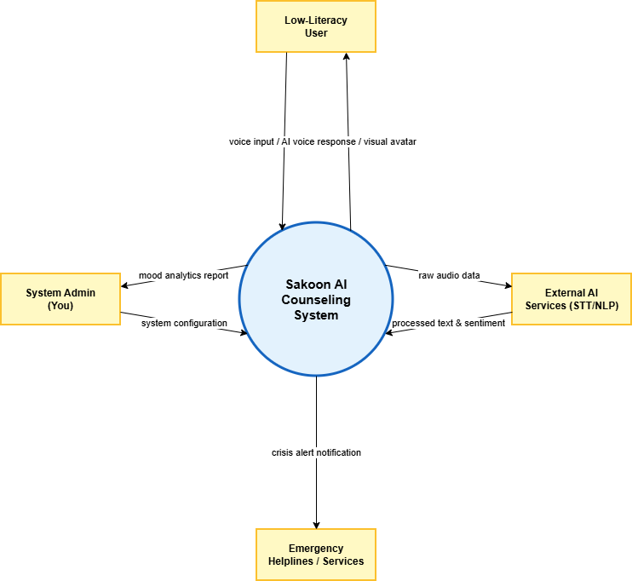

Figure 1: Context Diagram – Sakoon AI Couseling system [1]

Data Flow Diagram Level 0
The single circle that represented the entire Sakoon AI System on the context diagram has been subdivided into five major functional processes. While the context diagram showed only external interfaces, this Level 0 DFD provides a big-picture view of how data moves through the system, pulls information from data stores, and transforms inputs into therapeutic outputs.
Figure 2: Data Flow Diagram – Sakoon AI System[1]

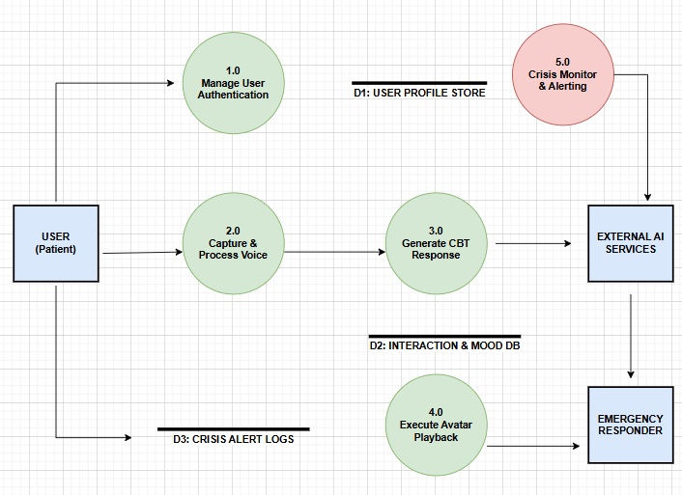
The single circle that represented the entire Sakoon AI System on the context diagram has been subdivided into five major processes (the process bubbles). This level provides visibility into how data is transformed, where it is stored, and how it flows between internal modules.
Each process that appears as a separate bubble on the level 0 diagram can be further expanded into a separate DFD to reveal more detail about its functioning

Requirements analysis

List of Actors
The system boundary for Sakoon AI includes the voice-based interface, the CBT logic engine, and the crisis monitoring module. The following three actors are the primary stakeholders interacting with the system:
- User (Patient): This person uses the app to talk to the 3D Avatar. They seek emotional support, participate in voice sessions, and view their mood progress.
  - User Story: As a User, I want to record my thoughts in Urdu so that I can receive therapy without needing to read or write.
- Administrator: This person manages the platform's technical backend. They are responsible for user account management, system performance, and reviewing data logs.
  - User Story: As an Admin, I want to manage user access and system settings to ensure the platform remains stable and secure.
- Mental Health Professional: This person represents the clinical expert who provides the CBT (Cognitive Behavioral Therapy) frameworks and is notified in case of a mental health crisis.
  - User Story: As a Mental Health Professional, I want to receive alerts for high-risk users so that I can provide human intervention when the AI detects a crisis.

Product Backlog
Sakoon AI is an AI-driven mental health platform designed to provide accessible counseling through a 3D avatar. It is specifically built for users who prefer voice interaction over text, particularly focusing on the Urdu language to bridge the gap for low-literacy populations.
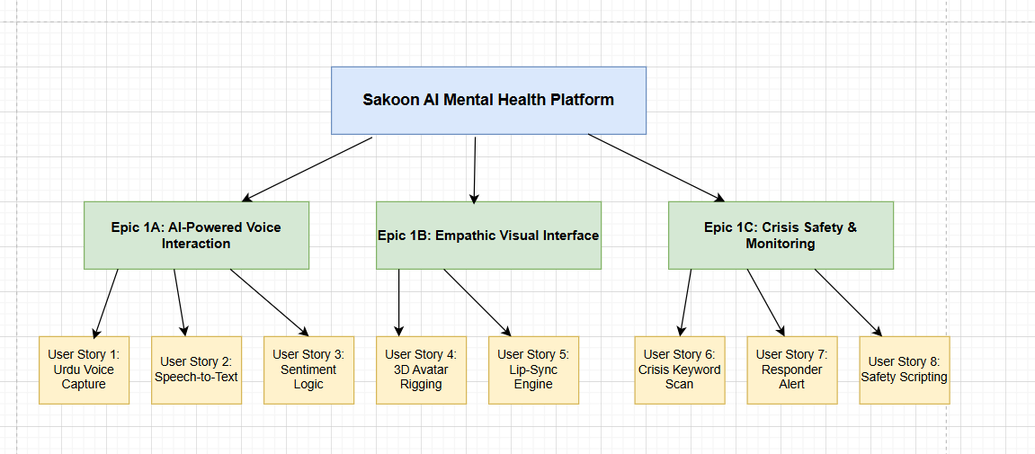
Sprint: In Agile project management, a sprint is a fixed-length period during which a team works to complete a set of tasks and deliver a potentially shippable increment of product. Sprints are typically one to four weeks long, but two to three weeks is a common duration. For Sakoon AI, a sprint is a 2-week period where the development team completes specific tasks like "Voice Recognition Optimization" or "Avatar Animation Rigging" to deliver a functional part of the app.

Epic: An epic is a user story that is too large to fully implement in a single iteration. It is a multi-sprint project goal or a broad area of functionality that requires significant development effort.
- Scope: Covers multiple releases or iterations and often spans across several teams, such as the entire emotional intelligence or 3D rendering engine.
- Purpose: Provides a high-level overview of the project and helps in prioritizing and planning the release.
- Example: "Develop Real-time Urdu Voice Therapy Module".

Feature: A specific piece of functionality or a deliverable within an Epic that provides value to the user.
- Scope: Smaller than an Epic and can be developed and released within a single iteration or two.
- Purpose: Breaks down the Epic into manageable chunks and guides the development process.
- Example: "Urdu Speech-to-Text," "Sentiment Analysis Engine," or "3D Avatar Lip-Sync" within the "Voice Therapy" Epic.

User Story: A user story is a “short, simple description of a feature told from the perspective of the person who desires the new capability, usually a user or customer of the system”. User stories are sized so as to be fully implementable in a single iteration.
- Scope: The smallest unit of work that can be delivered within a sprint.
- Purpose: Captures the requirements of a feature in a way that is easy for developers to understand and implement.
- Format: As a <type of user>, I want <some goal> so that <some reason OR Benefit>.
- Example: "As a user, I want to speak my thoughts in Urdu so that the system can understand my feelings without me having to type".

Acceptance Criteria: A set of conditions or rules that a user story must satisfy to be considered "done" and accepted by the product owner.
- Purpose: To define what success looks like for a user story.
- Example User Story: As a user, I want the AI to detect my crisis keywords so I can get immediate help.
- Acceptance Criteria:
  - The system must recognize "self-harm" or "suicide" keywords in Urdu.
  - The system must immediately trigger a high-priority alert to the Mental Health Professional.
  - The AI response must switch to a "Safety Script" instead of a general conversation.

Story Point: In Agile, story points are a relative unit of measurement used to estimate the effort required to complete a user story or other piece of work. They are not time-based but rather represent the complexity and effort relative to other items on the backlog.
- Relative, not absolute: Story points are assigned relative to other tasks, meaning a story with 2 points is roughly twice as complex as a story with 1 point.
- Common scales: Teams often use scales like Fibonacci (1, 2, 3, 5, 8, 13...).
- Example: Integrating a simple "Login" might be 2 points, while developing the "Urdu Sentiment Analysis Engine" might be 13 points due to its high complexity.

Backlog Grooming: It is a process where the product owner and development team collaboratively review and refine the product backlog. It focuses on ensuring the backlog is well-defined, prioritized, and ready for upcoming sprint cycles.
- Refining User Stories: Making sure the "Avatar Emotions" story is clear, concise, and easy to understand.
- Breaking down large items: Dividing complex tasks, like the "Full CBT Module," into smaller, more manageable units such as "Introduction to CBT" and "Daily Mood Check-in".
- Prioritizing items: Moving "Crisis Detection" to the top of the list because user safety is the highest priority.
Benefits for Sakoon AI:
- Increased velocity: By optimizing the backlog, the team can work more efficiently and deliver more value.
- Reduced risk: By defining "Crisis Detection" early, we minimize the risk of scope creep and delays, and ensure the AI does not give unsafe advice.
- Improved team morale: When the team understands what they are working on and how their code helps users with mental health struggles, they are more motivated and engaged.

Sub headings in this section are epics and each epic contain multiple user stories.

Course Catalog

Therapy Session Catalog
PB-ID | User Story | Priority | Acceptance Criteria | Story Points | Status
TC-01 | As a Professional, I can create a session description so that users can understand what the therapy session covers. | High | - Professional can add/edit session details.  - Description is saved and displayed on the app. | 3 | Pending
TC-02 | As a Professional, I can maintain my clinical bio so that users know my expertise and background. | Medium | - Bio can be updated by the therapist.  - Bio appears when a user selects that therapist's session. | 2 | Pending
TC-03 | As a User, I can view a detailed page about a session so that I can learn about the techniques (CBT, etc.) used. | High | - Page shows title, description, and session duration. | 3 | Pending
TC-04 | As a User, I can browse a catalog of all therapy modules so that I can pick the right one for my mental state. | High | - Catalog lists all sessions (Anxiety, Stress, etc.).  - Voice-based search works. | 5 | Pending
Account Management
ID | User Story | Priority | Acceptance Criteria | Story Points | Status
AM-01 | As a User, I can sign up and login using voice/biometrics so that I can access my private data easily. | High | - Secure login with voice/password.  - User is redirected to their dashboard. | 5 | Pending
AM-02 | As an Admin, I can monitor user logs to ensure system stability and ethical AI behavior. | High | - Admin can view system performance logs.  - Ethical guidelines are monitored. | 3 | Pending

Session Interaction (AI Avatar)
ID | User Story | Priority | Acceptance Criteria | Story Points | Status
SI-01 | As a User, I can speak to the 3D avatar so that I can have a natural voice conversation. | High | - Real-time audio recording and processing.  - Avatar responds with natural lip-syncing. | 8 | Pending
SI-02 | As a User, I can pause a session and resume later so that I can take a break if I feel overwhelmed. | Medium | - Session state is saved.  - User can restart from the last dialogue point. | 3 | Pending

Safety & Crisis Monitoring
ID | User Story | Priority | Acceptance Criteria | Story Points | Status
SM-01 | As a Professional, I want the system to flag crisis keywords so that I am alerted to potential self-harm. | High | - Real-time transcript scanning for red flags.  - Immediate notification sent to the professional. | 5 | Pending
SM-02 | As a User, I want the AI to switch to a safety mode if I am in distress so that I receive immediate coping advice. | High | - AI detects high distress and provides calming exercises.  - Safety resources are displayed on screen. | 5 | Pending

Reporting & Mood Tracking
ID | User Story | Priority | Acceptance Criteria | Story Points | Status
RP-01 | As a User, I can see my weekly mood chart so that I can visualize my progress over time. | Medium | - Charts generated from session sentiment analysis.  - Progress is displayed in an easy-to-read format. | 3 | Pending
RP-02 | As an Admin, I can generate reports on platform usage to see how many people are being helped. | Medium | - Anonymized aggregate data of active users.  - Exportable report for stakeholders. | 3 | Pending

Non-Functional Requirements
ID | User Story | Priority | Acceptance Criteria | Story Points | Status
NFR-01 | As a User, I want the system to work on slow internet so that I don't lose connection during therapy. | High | - Audio compression used for low bandwidth.  - Minimal latency (under 2 seconds). | 5 | Pending
NFR-02 | As a User, I want my data to be encrypted so that my private therapy sessions remain confidential. | High | - End-to-end encryption for audio and text.  - Compliance with mental health data privacy standards. | 8 | Pending

Figma UI/UX Designs
Login Prototype 1:
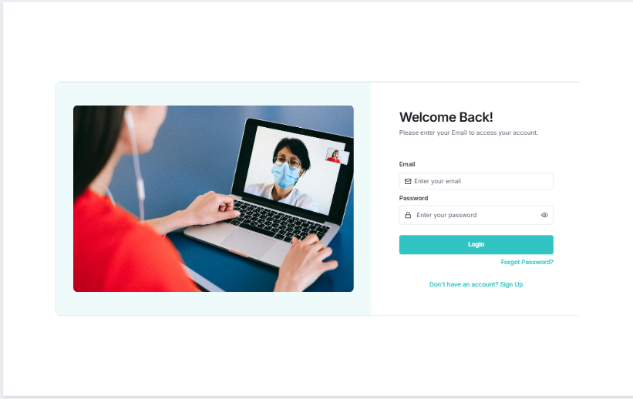
Chat Session Prototype 2:
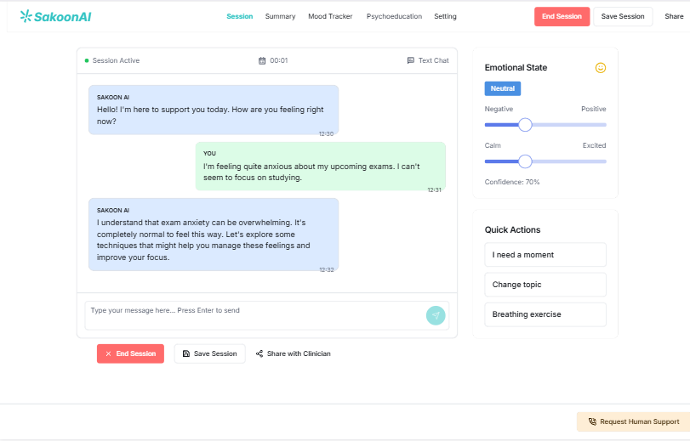
Mood Tracking system Prototype 3:
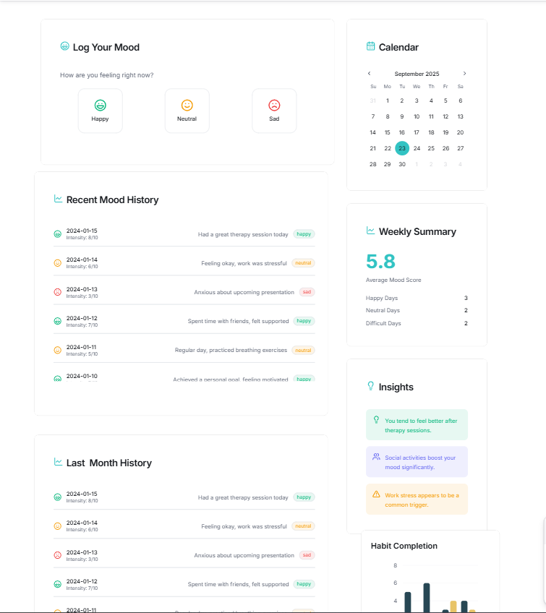

Setting Page Prototype 4:
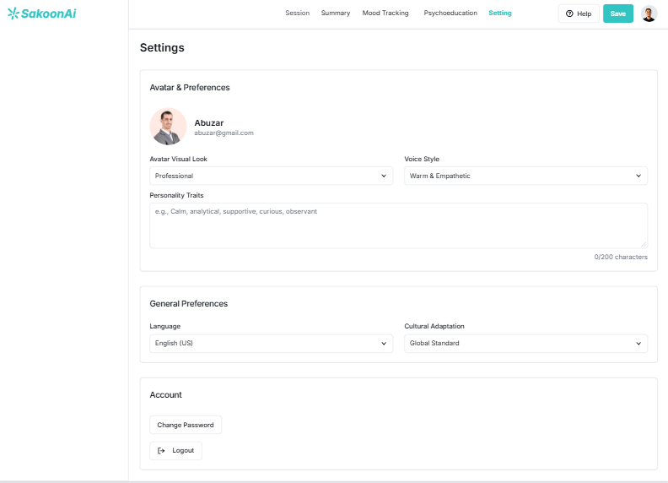

Prototype 5:
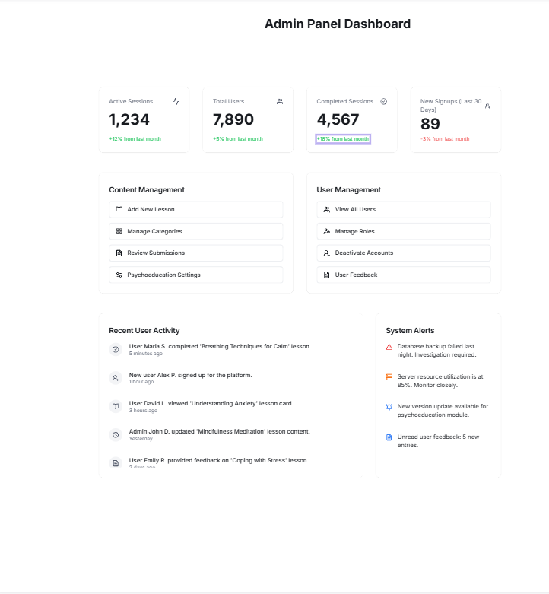
Prototype 6:
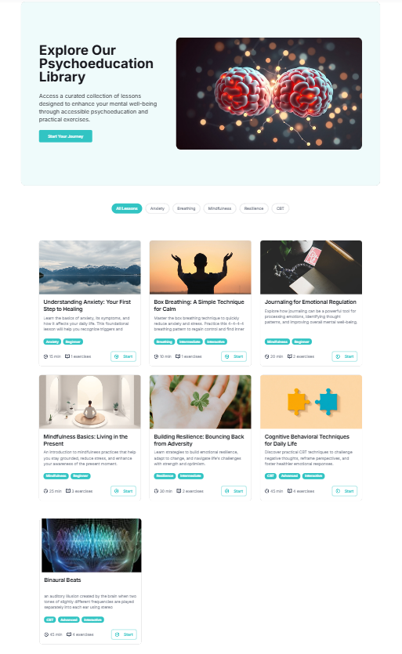

Project Planning and Execution using Sprints

Jira
Students would provide the link and credentials of their Jira project management credentials where they are managing their epics, stories and tasks

Slack
Students would provide the link and credentials of their slack communication management where they would be managing their project communication.

Github Repository
Students would provide the link and credentials of their Github repo where they would be maintaining their code Baselines.

Sprint 1
The goal of the first Sprint is to implement core functionalities including user authentication, dashboard, and profile management.

Sprint 1 Planning Meeting Minutes
The goal of the first Sprint is to implement core functionalities including Urdu Voice Capture setup, Avatar Basic Rendering, and User Profile Management ( literacy level selection).

Sprint 1 Planning Meeting Minutes
- Project Name: Sakoon AI
- Sprint Name: Sprint 1 – Voice Core & Avatar Foundation
- Sprint Duration: April 25, 2024 – May 25, 2024 (4 weeks)
- Meeting Date: April 24, 2024
- Attendees: Abuzar, Moin, Noor ul Ain, Ayesha

Backlog Items with high priority, high risk and Architecturaly Significant:
The following features are extracted from Product Backlog
Table 4: Selected Features of Product Backlog
PB-ID | User Story | Priority | Acceptance Criteria | Story Points | Status
AM-01 | As a User, I can record my Urdu voice so the AI can process my thoughts. | High | - Mic records audio clearly.  - Audio file is saved for STT processing. | 5 | Pending
AM-02 | As a User, I can log in and select my literacy level so the AI talks accordingly. | High | - Voice/ID login works.  - Literacy level (Low/High) is saved. | 3 | Pending
AM-03 | As a User, I can see the 3D Avatar on my dashboard so I feel a human connection. | High | - Avatar renders on screen.  - Idle animations (breathing/blinking) work. | 8 | Pending
AM-04 | As a Professional, I can view user mood summaries on a dashboard. | Medium | - Dashboard displays sentiment tags.  - User privacy is maintained. | 5 | Pending
AM-05 | As a User, I can browse available therapy topics via voice commands. | Medium | - Voice search returns relevant topics.  - Navigation is hands-free. | 5 | Pending
AM-06 | As a User, I can sign up and provide emergency contact info for safety. | High | - User data saved securely.  - Emergency contact linked to profile. | 3 | Pending
Table 5: Team Capacity Sprint 1
Member | Days Available | Hours/Day | Total Hours
Abuzar | 10 | 6 | 60
Moin | 10 | 6 | 60
Noor ul Ain | 9 | 5 | 45
Ayesha | 8 | 6 | 48
Action Items before Sprint Starts:
- ü Confirm GitHub repo for AI models – Moin
- ü Share Avatar 3D design templates – Noor ul Ain
- ü Create and Assign Jira tasks – Abuzar
- ü Setup Urdu STT (Speech-to-Text) API keys – Ayesha

Sprint 1 Backlog
The following tasks are extracted from Product Backlog features.

Table 6: Sprint 1 Backlog
SP-ID | Task Name | Related PB ID | Assigned To | Status | Est. Effort (Hrs) | Act. Effort (Hrs) | Comments
S1-1 | Design Voice-First Dashboard UI | AM-01 | Abuzar | In Progress | 5 | 2 | UI mockup focus on large icons/voice buttons.
S1-2 | Implement Urdu STT API | AM-01 | Moin | In Progress | 10 | 4 | Testing Google/Whisper Urdu accuracy.
S1-3 | Basic 3D Avatar Rendering (React-Three-Fiber) | AM-03 | Ayesha | In Progress | 12 | 5 | Avatar is visible, fixing lighting issues.
S1-4 | User Profile & Literacy Level logic | AM-02 | Noor ul Ain | In Progress | 6 | 3 | Literacy state managed in Redux/Context.
S1-5 | Implement Voice Login Auth | AM-02 | Moin | Pending | 8 | 1 | Researching voice biometric security.
S1-6 | Create Emergency Alert Mechanism | AM-06 | Noor ul Ain | In Progress | 7 | 2 | SMS API integration for emergency contact.
S1-7 | Design DB Schema for Conversations | AM-06 | Moin | In Progress | 8 | 4 | Designing tables for encrypted audio logs.
S1-8 | Avatar Idle Animations (Blinking) | AM-03 | Ayesha | Pending | 5 | 0 | Will start after rendering is stable.
S1-9 | Develop Professional Mood Dashboard | AM-04 | Abuzar | Pending | 7 | 0 | Designing charts for mood tracking.
S1-10 | Setup CI/CD for AI Model Deployment | AM-06 | Moin | Complete | 6 | 6 | Pipeline is ready for backend deployment.
S1-11 | Integration: Voice Input to 3D Avatar Reaction | AM-01 | Ayesha | Pending | 10 | 0 | Needs STT completion first.

Sprint 1 Design Class Diagram
The Design Class Diagram for Sprint 1 illustrates the structural architecture of the Sakoon AI platform, focusing on the core modules: User Authentication, Voice Processing Engine, and Avatar Rendering Controller. Each class is designed to handle specific tasks defined in the Sprint 1 Backlog.
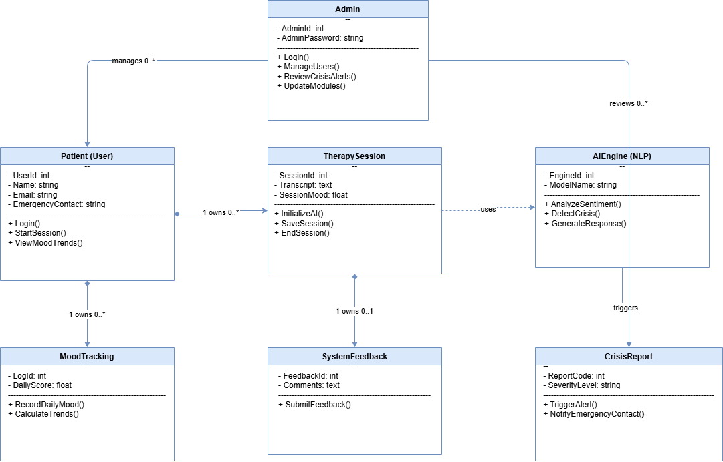
Figure 20: Class diagram of Sprint 1 features [4]

Sprint 1 Sequence Diagram
The sequence diagram for Sprint 1 illustrates the dynamic interaction between the User, the Voice Engine, the AI Controller, and the 3D Avatar. It specifically models the process of capturing Urdu speech, converting it to text, and triggering an empathetic response from the avatar.. [2]

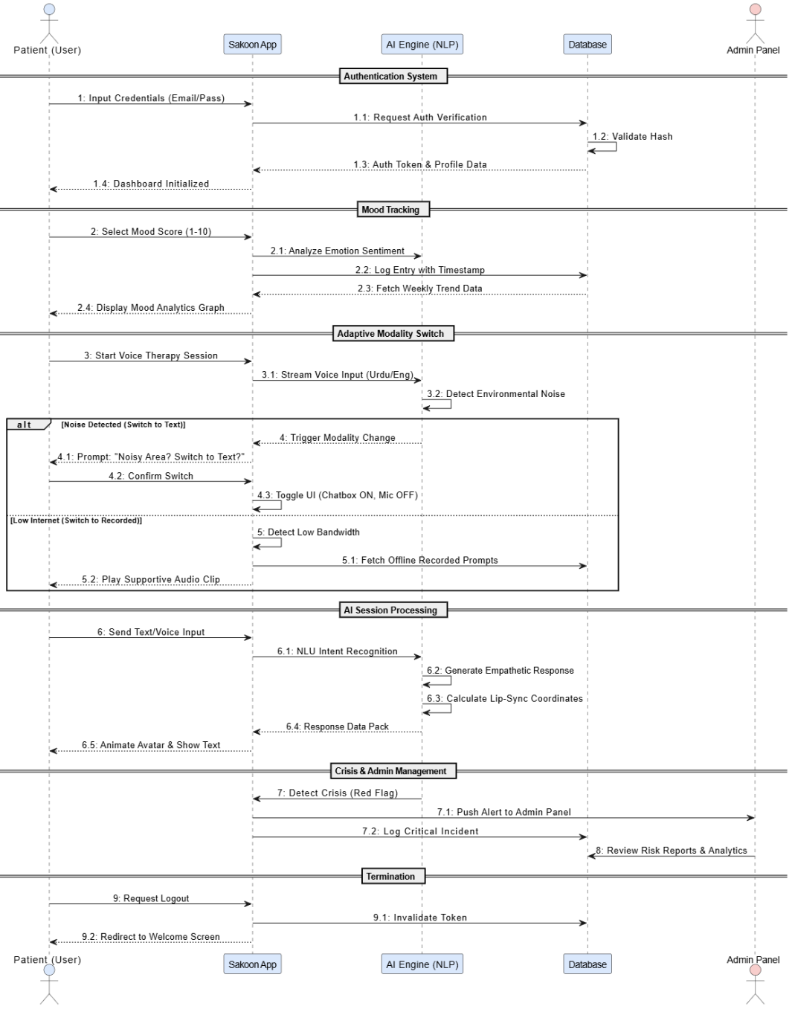
Figure 21: Sample Sprint 1 Sequence diagram 1 [2]

Sprint 1 Decision Table
A software system is often governed by complex logic, with various combinations of conditions leading to different system behaviors. In user stories involving mental health and user safety, it is advisable to create a decision table in order to better understand possible combinations. Testers are also advised to develop a separate test case for each possible combination that checks whether the system is working fine in all those complex possible combinations of input and outputs.
The table below shows a decision table for the logic that governs whether the Sakoon AI system should trigger an emergency alert, switch to a safety script, or continue a normal conversation. Four factors influence this decision:
- Crisis Keywords Detected: Whether the Urdu Speech-to-Text engine identifies high-risk words related to self-harm or distress.
- Sentiment Score Low: Whether the AI sentiment analysis determines the user's emotional state is severely negative.
- High-Risk User Profile: Whether the user has a history of severe mental health incidents stored in their profile.
- Consent for Professional Help: Whether the user has previously authorized the system to contact their emergency contact or therapist in case of a crisis.
Table 7: Sakoon AI Decision Table
Requirement Number
Condition | 1 | 2 | 3 | 4 | 5
Crisis Keywords Detected | F | T | T | T | T
Sentiment Score Low | — | F | T | T | T
High-Risk User Profile | — | — | F | T | T
Requester has given Consent | — | — | — | F | T
Action
Continue General Conversation | X
Switch to Safety Script |  | X | X | X | X
Log High-Priority Incident |  |  | X | X | X
Trigger Emergency Alert |  |  |  |  | X

Description of Decision Rules:
- Rule 1: If no crisis keywords are detected (False), the system continues the general conversation regardless of other factors.
- Rule 2: If keywords are detected but the overall sentiment is not critically low, the AI switches to a calming Safety Script but does not log a crisis.
- Rule 3: If keywords are detected and sentiment is low, the system switches to a Safety Script and logs the incident as High-Priority for the therapist to review.
- Rule 4: If the user is identified as a High-Risk profile, even without immediate consent, the safety script remains active and the incident is logged.
- Rule 5: If all conditions are met, including the user's prior consent, the system performs the ultimate action of triggering a real-time Emergency Alert to the assigned professional.

Figure 23: Sample Sprint 1 Decision Table Sakoon AI System

Sprint 1 Extended Test Cases
Separate Test cases should be made against each user story to test the functionality.
Table 7: Sprint 1 Extended Test Case
Test Case ID: TID1 | Test Designed By: Ayesha
Epic Name and Backlog ID: Account Management AM-06 | Test Design Date: 17/05/2024
Test Priority: High | Test Executed by: Noor ul Ain
Test Title: Verify Account Creation with Literacy Level Selection | Test Executed Date: 21/05/2024
Description: Make sure a user is easily able to register an account with correct details and select their literacy level for AI adaptation.
Selenium Web Driver Test created: Yes
Dependencies: None
Step | Test Step | Test Data | Expected Result | Actual Result | Status
1 | Select the option to register account. |  | The location of the registration form is shown next. | Same as expected result | Pass
2 | Enter valid data in the username field. | Username: Abuzar_Awan | The username is correct meaning that it is properly typed. | Same as expected result | Pass
3 | Enter valid data in the Email field. | Email: abuzar@sakoon.ai | The valid email address field is being filled appropriately. | Same as expected result | Pass
4 | Enter valid data in the password field (12 chars, capital, small, number, special). | Password: S@koonAI2024! | The password is typed accurately. | Same as expected result | Pass
5 | Click the “Register” button. |  | System displays the message that a link has been sent on the given email for verification. | System displays the message that a link has been sent on the given email. | Pass
6 | User checks inbox and click on the link provided to Activate the account. |  | The user is redirected to the login page with message shown that account has been activated successfully. | The user is redirected to the login page as expected. | Pass
Post Condition:
- A new account is created to be used by a new user in Sakoon AI.
- Using the registered e-mail address and password, the user can log in.

Sprint 1 Review Meeting

Sprint: Sprint 1 – Initial Setup & Core Architecture
Review Date: May 25, 2024
Duration: 1 hour
Facilitator: Product Owner / FYP Supervisor
Attendees: Abuzar, Moin, Noor ul Ain, Ayesha
The following table shows the status of tasks assigned to team members in the Sprint planning meeting.
Table 8: Status of Sprint 1 Backlog
ID | Task Name | Related Product Backlog ID | Owner | Status | Notes
S1-1 | Design Voice-First Dashboard UI | AM-01 | Abuzar | Completed | UI mockup with voice-first controls complete.
S1-2 | Implement Urdu STT API | AM-01 | Moin | Completed | Tested Urdu Speech-to-Text on Postman.
S1-3 | Basic 3D Avatar Rendering | AM-02 | Ayesha | Completed | Avatar model loading and rendering done.
S1-4 | Integrate backend with dashboard | AM-02 | Noor ul Ain | Completed | Integration done and tested with user state.
S1-5 | Develop literacy-based profile feature | AM-03 | Moin | Completed | Literacy level adaptation logic completed.
S1-6 | Test profile management module | AM-03 | Ayesha | Completed | Profile management tested and working.
S1-7 | Create Urdu notification templates | AM-04 | Abuzar | Completed | All 10 Urdu templates created.
S1-8 | Develop notification service | AM-04 | Abuzar | Completed | Notification mechanism for crisis alerts done.
S1-9 | Implement secure voice log upload | AM-05 | Moin | Completed | Mechanism working and encrypted.
S1-10 | Test voice upload functionality | AM-05 | Noor ul Ain | Completed | Tested and working fine.
S1-11 | Set up development environment | N/A | Abuzar | Completed | AI environment set up is done and working.
S1-12 | Design DB schema for users/sessions | AM-06, AM-01 | Moin | Completed | DB created with all encrypted tables.
S1-13 | Create static landing page for login | AM-06, AM-01 | Ayesha | Completed | Page created and delivered from Figma.
S1-14 | Draft Avatar interaction UI | AM-01 | Noor ul Ain | Completed | Interaction UI screens done and delivered.
S1-15 | Setup Git repo and CI pipeline | AM-06 | Moin | Completed | Repo is set up with automated testing.
Demo Highlights:
- User Authentication: Live demo by Abuzar showing signup with literacy selection.
- Urdu Voice Capture: Moin walks through the automated STT pipeline.
- Avatar UI: Noor ul Ain shows the mobile-responsive avatar interaction mockup.
Sprint Goal Achievement:
- All core objectives were completed on time, reviewed, and meet the definition of done for Sakoon AI's foundation.
Feedback from Stakeholders:
Feedback Source | Comments
Internal QA (Noor ul Ain) | Avatar lip-syncing needs more refinement in Sprint 2.
Product Owner | Database encryption for patient privacy is well-implemented.
Team Feedback | The Urdu STT accuracy is better than expected.
Metrics Overview:
Metric | Value
Committed Story Points | 21
Completed Story Points | 21
Carryover Items | 0
Bugs Reported / Resolved | 2 / 2
What Went Well:
ü Team collaboration on Urdu language processing.
ü Early setup of 3D rendering pipeline.
ü Daily standups kept everyone aligned on AI task complexity.
What Could Be Improved:
- Need more diverse Urdu voice samples for testing.
- UI consistency between the Avatar screen and the Settings page.
Action Items / Next Steps:
Action Item | Owner | Due Date
Implement Avatar lip-sync validation | Ayesha | May 30, 2024
Add documentation for Urdu STT model | Moin | May 30, 2024
Refine dashboard icons for low-literacy users | Abuzar | May 30, 2024

Sprint 1 Retrospective Meeting
Sprint: Sprint 1 – Initial Setup & Core Architecture
Retrospective Date: May 25, 2024
Duration: 1 hour
Facilitator: Product Owner / FYP Supervisor
Attendees: Abuzar, Moin, Noor ul Ain, Ayesha
Sprint Overview
Goal: Establish the foundational architecture of the Sakoon AI platform and implement voice-based authentication and avatar rendering.
Sprint Duration: April 25, 2024 – May 25, 2024 (4 weeks)
What Went Well
ü Successful implementation of Urdu voice capture.
ü 3D Avatar rendering is stable across different browsers.
ü Team communication was excellent during integration phase.
ü Privacy-focused DB schema provides a secure foundation.
What Didn’t Go Well
- Avatar load times were high on low-end mobile devices.
- Some Urdu dialects were not recognized correctly by STT.
- Ambiguity in how "Literacy Mode" affects the UI layout.
Suggestions for Improvement
- Create a lightweight version of the 3D Avatar for mobile users.
- Include diverse regional voice data in the next training session.
- Improve story definitions for AI behavioral logic.
- Use pair programming for complex sentiment analysis algorithms.
Action Items:
Action Item | Owner | Due Date
Draft Avatar optimization guide for mobile | Ayesha | May 30, 2024
Research regional Urdu dialect support | Moin | May 30, 2024
Refine user stories for Sentiment Analysis | Noor ul Ain | May 30, 2024
Team Health Check:
- Team morale: Good
- Communication: Effective
- Tools and resources: Sufficient, but need more 3D design guidance.

Wrap-up:
Team expressed overall satisfaction with the sprint outcomes and is aligned on areas of improvement. Looking forward to Sprint 2.

System Architecture
Describe the system architecture, or simply provide the architecture diagram according to C4 Model.

System context Diagram
A System Context diagram is a good starting point for diagramming and documenting a software system, allowing you to step back and see the big picture. Draw a diagram showing your system as a box in the centre, surrounded by its users and the other systems that it interacts with.
Detail isn’t important here as this is your zoomed out view showing a big picture of the system landscape. The focus should be on people (actors, roles, personas, etc) and software systems rather than technologies, protocols and other low-level details. It’s the sort of diagram that you could show to non-technical people.

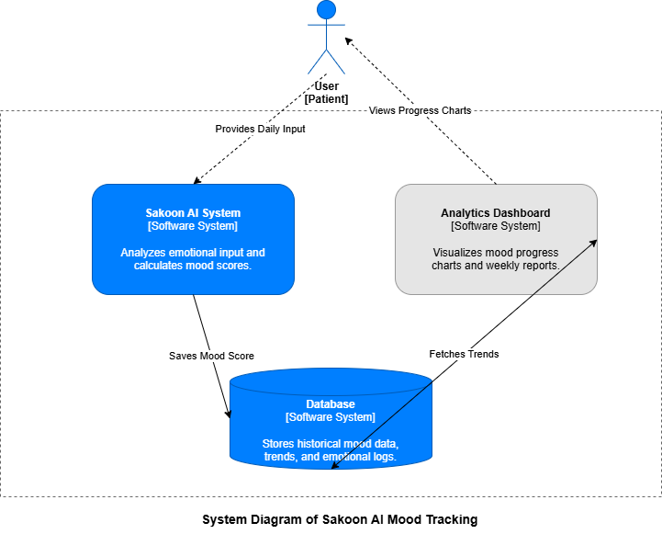
Figure 24: System context Diagram [5]

System Container Diagram
The Container diagram for Sakoon AI provides a high-level view of the software architecture, illustrating how the responsibilities of mental health support are distributed across different deployable units. It highlights the major technology choices, such as the Authentication and the Mood tracking system, and how they interact to provide a seamless user experience.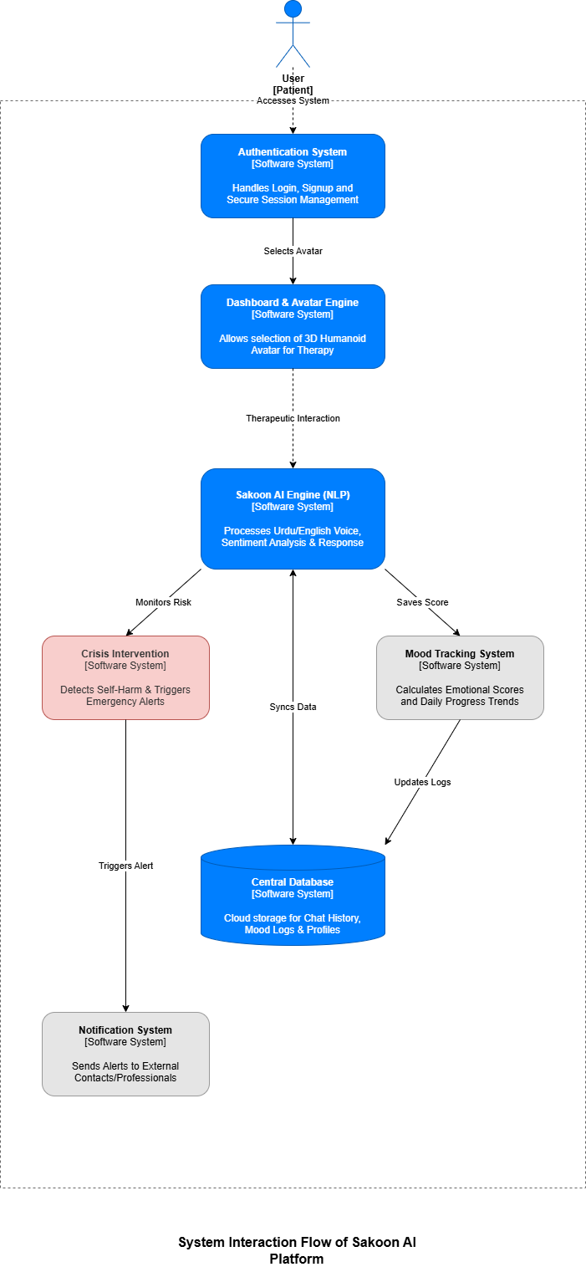
Figure 25: System container Diagram [5]

Component Diagram

The Component diagram for Sakoon AI zooms into the API Application container to identify the major structural building blocks that drive the system’s logic. Each component is a functional unit with specific responsibilities, interacting via internal method calls to process user requests.
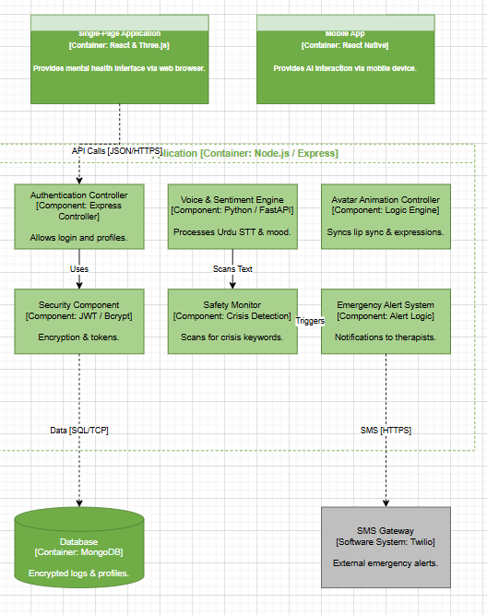

Figure 26: Component Diagram [5]

Code Diagrams
The Code diagram (Level 4) zooms into the most complex components of the Sakoon AI system. This level provides a structural view of how the implementation is handled within the codebase, specifically focusing on the AI Interaction Facade and Safety Protocol Manager.
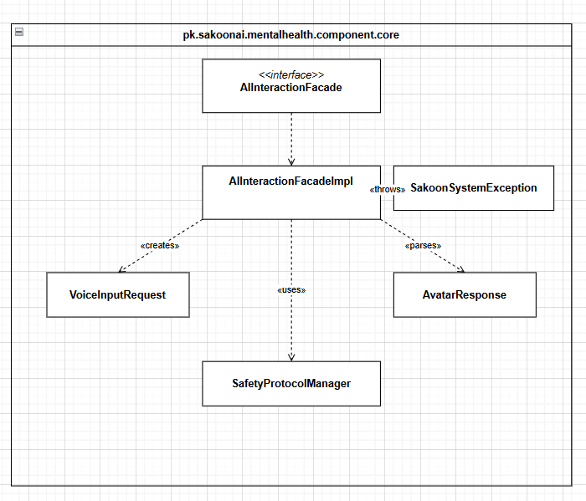
Figure 27: Code Diagram [5]

ERD
We now present the Sakoon AI database example to illustrate the ER modeling concepts for an AI-driven mental health platform. The system is designed to provide emotional support through Urdu-based interactions and manage crisis situations in real-time. The requirements for this database are as follows:
- User Management (USER): The system tracks individual patients (USER). Each user has a unique identifier (User_ID), a Literacy_Level (to customize the AI’s vocabulary), and a specific Urdu_Dialect to ensure accurate Speech-to-Text (STT) processing. Each user is the starting point of all interactions within the system.
- Interaction Sessions (AI_SESSION): A user initiates various sessions (AI_SESSION) over time. Each session is related to a single user and is identified by a unique Session_ID. To track usage patterns, the database stores the Start_Time, End_Time, and the Device_Type (e.g., Mobile App or Web Browser) used for the session.
- Conversation Tracking (CONVERSATION_LOG): Within a session, multiple interactions occur, recorded as logs (CONVERSATION_LOG). Each log is identified by a unique Log_ID. It stores the patient's spoken Urdu (Urdu_Utterance), the storage path for the voice file (Audio_Path), an English translation for secondary analysis (Translation_EN), and the AI_Response provided by the bot.
- Emotional Analysis (SENTIMENT_DATA): The system's "Voice & Sentiment Engine" analyzes each conversation log to produce sentiment data (SENTIMENT_DATA). This includes detecting the Primary_Mood (e.g., Anxiety, Depression, Joy), a Conf_Score (representing the AI's certainty), and an Intensity_Level of the emotion.
- Safety & Crisis Management (CRISIS_ALERT): If the "Safety Monitor" detects high-risk keywords or severe negative sentiment, it triggers an alert (CRISIS_ALERT). Each alert has a unique Alert_ID and a Severity_Lvl (coded as 1 for Mild, 2 for Moderate, and 3 for Critical/Suicidal).
- Emergency Support (EMERGENCY_CONTACT): Users nominate their trusted circle as emergency contacts (EMERGENCY_CONTACT). The database stores each contact's unique Contact_ID, Contact_Name, Phone_Number, and their Relation to the user. When a high-severity alert is triggered, these contacts are notified immediately.
- Professional Intervention (THERAPIST): The platform also coordinates with mental health professionals (THERAPIST). Each therapist has a unique Therapist_ID, Specialization (e.g., Clinical Psychologist), and Availability status. When a crisis alert is generated, the system ASSIGNS the case to a therapist, who then monitors the user's safety and coordinates with their emergency contacts.
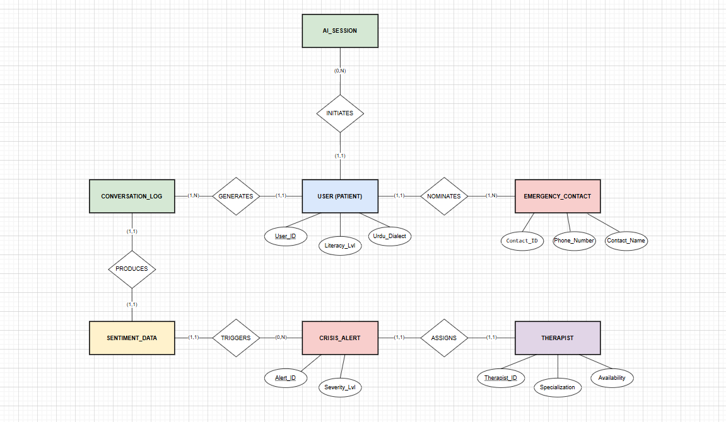

Figure 28: ER Diagram for University Scenario [3]

Data Dictionary
A Sakoon AI data dictionary is a collection of detailed information about the data entities used in this mental health support application. Collecting information about composition, data types, allowed values, and constraints into a shared resource identifies the data validation criteria (e.g., mood score ranges), helps developers write STT (Speech-to-Text) and sentiment analysis programs correctly, and minimizes integration problems between the AI model and the backend.

1. User Authentication & Profile Table
Data Element | Description | Composition or Data Type | Length | Values
User_ID | Unique identifier for each patient. | UUID (Primary Key) | 36 | System-generated
Full_Name | Patient's registered name. | Varchar | 100 | Alphabetic characters
Email | Registered email for login/OTP. | Varchar (Unique) | 255 | valid @email.com
Password_Hash | AES-256 encrypted password. | Varchar | 256 | Encrypted string
Account_Status | Security status of account. | Enum | - | Active, Locked
2FA_Enabled | Two-Factor Auth status. | Boolean | 1 | 0 (Off), 1 (On)

2. Therapeutic Session Table
Data Element | Description | Composition or Data Type | Length | Values
Session_ID | Unique ID for therapy session. | UUID (Primary Key) | 36 | System-generated
User_ID | Reference to the Patient. | UUID (Foreign Key) | 36 | Existing User_ID
Interaction_Mode | Current modality of session. | Enum | - | Voice, Text, Rec
Mood_Score | Sentiment score by AI. | Integer | - | 1 to 10
Sentiment_Tag | Emotional state tag. | Varchar | 50 | Calm, Anxious, etc.
Session_Summary | AI-generated discussion summary. | Text | - | Summary text

3. Modality & Environmental Logs
Data Element | Description | Composition or Data Type | Length | Values
Log_ID | Unique log for modality change. | BigInt (Primary Key) | Auto | Sequential Integer
Noise_Level_dB | Ambient noise detected. | Decimal | 5,2 | Numerical (dB)
Latency_ms | Network delay for prompts. | Integer | - | Milliseconds
Switch_Trigger | Reason for modality switch. | Varchar | 50 | Low BW, High Noise

4. Feedback & Accessibility Settings
Data Element | Description | Composition or Data Type | Length | Values
Feedback_ID | Unique ID for session feedback. | UUID (Primary Key) | 36 | System-generated
Star_Rating | AI empathy/helpfulness rating. | SmallInt | - | 1 to 5
UI_Contrast | Assistive high contrast setting. | Boolean | 1 | 0 (Normal), 1 (High)
Subtitle_Status | Real-time subtitle toggle. | Boolean | 1 | 0 (Off), 1 (On)

5. Crisis Management Table
Data Element | Description | Composition or Data Type | Length | Values
Alert_ID | Unique ID for crisis events. | UUID (Primary Key) | 36 | System-generated
Risk_Level | Severity of self-harm intent. | Enum | - | Low, Med, High
Emergency_Contact | Number for automated SMS. | Varchar | 15 | Valid Phone No.
Escalation_Flag | Moved to human handoff status. | Boolean | 1 | 0 (AI), 1 (Human)

Figure 29: Data Dictionary of Sakoon AI System [1]

Implementation details

Development Setup
List your tools and technologies and their role in development.

Deployment setup
How and where was your software deployed? Did you face any problems, how did you overcome these problems.

Algorithms
Entire code of software is not required. Just highlight your important (user defined/ improved) algorithms.

Constraints

Assumptions
Things we assume will be true.
e.g.:
- We will receive all necessary technical support from the engineers at cMeRun, Select and Mellon Bank to help design the interfaces between their systems and enGyro.
- All database maintenance will be handled by the client.
- There will be no real-time interfacing with any accounting systems.

System constraints
A constraint specifies how the system must operate or how it must be built

Restrictions
Constraints applied on the system by the client

Limitations
Services your software is unable to provide

Project Monitoring, control and traceability

Traceability Matrix

Section 1: Authentication & Core Interaction
PB-ID vs TID | TID1 | TID2 | TID3 | TID4 | TID5 | TID6 | TID7 | TID8 | TID9 | TID10
CC01 | ✓
CC02 |  | ✓
CC03 |  |  | ✓
CC04 |  |  |  | ✓
CC05 |  |  |  |  | ✓
CC06 | ✓ |  |  |  |  | ✓
CC07 |  |  |  |  |  |  | ✓
CC08 |  |  |  |  |  |  |  | ✓
CC09 |  |  |  |  |  |  |  |  | ✓
CC10 |  |  |  |  |  |  |  |  |  | ✓

Section 2: Advanced Performance & AI Logic
PB-ID vs TID | TID11 | TID12 | TID13 | TID14 | TID15 | TID16 | TID17 | TID18 | TID19 | TID20
BC-01 | ✓
BC-02 |  | ✓
BC-03 |  |  | ✓
BC-04 |  |  |  | ✓
BC-05 |  |  |  |  | ✓
BC-06 |  |  |  |  |  | ✓
BC-07 |  |  |  |  |  |  | ✓
BC-08 |  |  |  |  |  |  |  | ✓
BC-09 |  |  |  |  |  |  |  |  | ✓
BC-10 |  |  |  |  |  |  |  |  |  | ✓

Section 3: User Experience & Utility
PB-ID vs TID | TID31 | TID32 | TID33 | TID34 | TID35 | TID36 | TID37 | TID38 | TID39 | TID40
UX-01 | ✓
UX-02 |  | ✓
UX-03 |  |  | ✓
UX-04 |  |  |  | ✓
UX-05 |  |  |  |  | ✓
UX-06 |  |  |  |  |  | ✓
UX-07 |  |  |  |  |  |  | ✓
UX-08 |  |  |  |  |  |  |  | ✓
UX-09 |  |  |  |  |  |  |  |  | ✓
UX-10 |  |  |  |  |  |  |  |  |  | ✓

Section 4: Specialized AI Modules
PB-ID vs TID | TID41 | TID42 | TID43 | TID44 | TID45 | TID46 | TID47 | TID48
AI-01 | ✓
AI-02 |  | ✓
AI-03 |  |  | ✓
AI-04 |  |  |  | ✓
AI-05 |  |  |  |  | ✓
AI-06 |  |  |  |  |  | ✓
AI-07 |  |  |  |  |  |  | ✓
AI-08 |  |  |  |  |  |  |  | ✓

Section 5: Compliance & Adaptive Logic
PB-ID vs TID | TID49 | TID50 | TID51 | TID52 | TID53 | TID54 | TID55 | TID57 | TID58 | TID60
LA-01 | ✓
LA-02 |  | ✓
LA-03 |  |  | ✓
LA-04 |  |  |  | ✓
LA-05 |  |  |  |  | ✓
LA-06 |  |  |  |  |  | ✓
LA-07 |  |  |  |  |  |  | ✓
LA-08 |  |  |  |  |  |  |  | ✓
LA-09 |  |  |  |  |  |  |  |  | ✓
LA-10 |  |  |  |  |  |  |  |  |  | ✓

Results/Output/Statistics

%completion
Use the matrix & values from 7 to show that all requirements are being fulfilled.

%accuracy
Use the matrix & values from 7 to show that all requirements have been implemented correctly.

%correctness
Use the matrix & values from 7 to show that all requirements have been tested to be conforming to requirements.

Conclusion

Future work

Bibliography
Use IEEE or ACM format for citations

Books
- Karl E Wiegers and Joy Beatty. 2013. Software Requirements 3. Microsoft Press, USA.
- Craig Larman. 2001. Applying UML and Patterns: An Introduction to Object-Oriented Analysis and Design and the Unified Process (2nd. ed.). Prentice Hall PTR, USA.
- Ramez Elmasri and Shamkant B. Navathe. 2015. Fundamentals of Database Systems (7th. ed.). Pearson.
- Martin Fowler. 2003. UML Distilled: A Brief Guide to the Standard Object Modeling Language (3rd. ed.). Addison-Wesley Longman Publishing Co., Inc., USA.

Journals

Articles

Research papers

Other References
5 https://c4model.com/

Appendix

Glossary of terms

Pre-requisites
Must use contents of development/ deployment setup & external system dependencies

